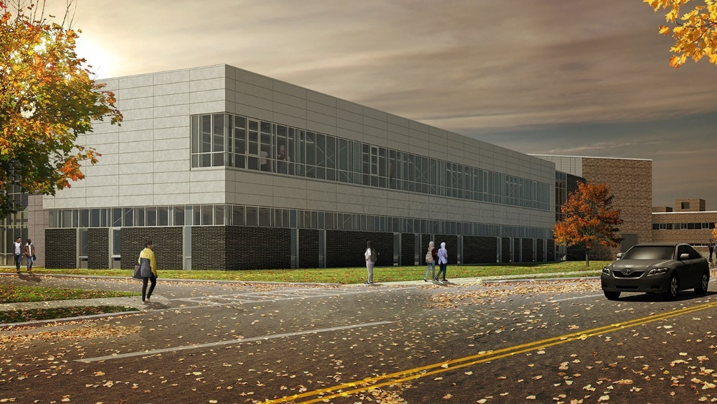

MINIMUM CAPACITY :-
The Minumum intake capacity
of students is between 300-420
children

LIBRARY :-
The Libarary is Available.

CANTEEN:-
The Canteen Facility is Available.

BOARDING :-
No availablility of boarding.

SPORTS :-
There are different categories
sports available.
Girls Volleyball
Boys Volleyball
Football

GIFFEN MEMORIAL SCHOOL
ALBANY - SCHOOL

School Detail :-
Giffen Memorial Elementary School is an exciting learning place where young people develop their natural gifts and abilities as they gain confidence in their potential. Students grow to become well-adjusted, independent thinkers as they explore their intelligences
Giffen Memorial Elementary School is an exciting learning place where young people develop their natural gifts and abilities as they gain confidence in their potential. Students grow to become well-adjusted, independent thinkers as they
explore their intelligences; they realize the satisfaction of productive teamwork as they collaborate with others from a variety of racial, ethnic and economic backgrounds. Stimulating
activity integrates themes and basic content, resulting in higher scholastic achievement for all.



